Housing Education and Research Association
581 Stargazer Way, Florence, MT 59833
Phone: (406) 580-4836

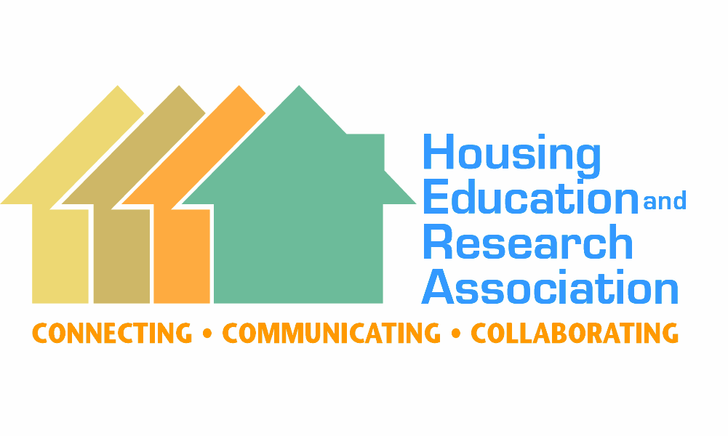
Please circle membership category: ACTIVE STUDENT EMERITUS

Membership year: January 1st to December 31st

ACTIVE: Any person/organization interested in the purposes of HERA. These members have voting privileges and receive the Housing & Society journal. Libraries are not eligible.

STUDENT: Persons enrolled as students on at least a half-time basis. These members receive the Housing & Society journal but do not have voting privileges. (Former active members who return to student status do not lose their voting rights.)

EMERITUS: Any retired person who was formerly an active member. These members receive all the benefits and privileges of active membership.

Pricing:
Active: $125 or $130 online; Student: $55 or $60 online; Emeritus: $65 or $70 Mail payment to: HERA, 581 Stargazer Way, Florence, MT 59833
Online payment (PayPal): housingeducators.org/membership
For questions, contact: Barbara Allen, Executive Director, heraballen@gmail.com

Name: _ University/Organization: _ Work Address:

City:
State: _
Zip: _

Email:
Work Phone: _

Home Address:
HERA Membership Includes:
- Subscription to the research journal Housing & Society
- Annual Conference: HERA’s annual conference is scheduled in a different geographic region of the U.S. or international site each year. Topics of current housing issues are presented by members as well as state, national and international housing leaders. Sessions, posters, and group discussions are held on the education, research and extension implications of current housing trends and research. Conference proceedings include referred abstracts of papers presented.
- Educational Resources: HERA has available on-line and for purchase educational resources developed by members and committees. These include teaching tips and classroom/program ideas.
- Awards: Tessie Agan Scholarship, Kenneth Tremblay Early Career Housing Award, Housing Impact Award, Distinguished Service Award, International Ambassador Fellowship Award, Secondary Education Housing Teaching Award, and the Extension Housing Outreach Award.

Library Journal Subscriptions

Libraries may subscribe to the journal, Housing & Society, the official publication of HERA. To subscribe, go to: housingeducators.org/publications and click on “Access Journal Articles” button. (Online access only =
$375 or print AND online access = $441.)

At HERA our mission is to increase the effectiveness of housing education at all levels, develop expertise in and expand the out- reach of educators and researchers by coordinating efforts among professionals in housing, disseminate information on current developments in housing and promote recruitment of students to advance the study of housing and to increase the quality and quantity of professionals in the field.

